Greenstone – Junior Sustainability Consultant

Description
At Greenstone, we provide award-winning software solutions that enable our clients to achieve their sustainability goals and become responsible businesses. Greenstone has been providing Software-as-a-Service (SaaS) solutions for over 14 years and our clients are currently in over 100 countries worldwide across 15 industry sectors.

Through our suite of sustainability, supply chain and ESG software solutions we enable our clients to collect, manage and analyze the data required to inform and support their sustainability journeys. We build long-term partnerships with our clients and constantly develop and innovate to stay ahead of their evolving sustainability management and reporting requirements.

Greenstone has a team of specialists that take an active interest in our clients’ ambitions and ensure that our solutions and services enable their success. In a context of constant change and limited sustainability resource, clients can rely on the Greenstone team to help them achieve their sustainability goals, and keep them on top of reporting trends, frameworks and legislation. As part of this effort, our in-house team of developers use cutting edge innovation and technology to constantly evolve Greenstone’s suite of software solutions.

Headquartered in London, Greenstone is a dynamic entrepreneurial company. Greenstone recently expanded, opening an office in Manhattan, New York where this role would be based supporting Greenstone’s current and rapidly growing North America client base.

Working in the dynamic and rapidly growing area of sustainability and ESG, requires a social, energetic, dedicated and hard-working environment in the office. We value teamwork and we are passionate about what we do. We’re committed to developing our skills and careers, and also ensure that we maintain a focus on our culture, individual personal development and having fun both inside and outside the office.

About the role
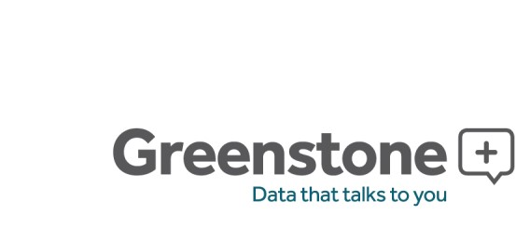
This is a unique opportunity to join our client services team and work directly with the leadership team. We are looking for star performers who have at least 2 years of experience working in related fields (e.g. carbon management, sustainability or broader non-financial reporting) and a broad range of knowledge of climate change and sustainability (e.g. policy, methodologies and frameworks, legislative requirements voluntary market developments).

The key responsibilities of the roles will include:
- Lead client implementations of Greenstone’s software solutions, acting as the single point of contact for clients and escalating issues when required.
- Support clients with detailed data analysis and handling queries (typically large and complex Excel data sets), identifying opportunities to improve delivery and the overall client experience.
- Conduct high-level analyses of clients’ sustainability reporting requirements, providing guidance and education where required.
- Ensure data and calculated output of Greenstone software is ready to be handed over to clients and has gone through the required Greenstone QA process.

Page 2 of 2
- Monitor national and international sustainability and wider non-financial reporting standards and protocols, understanding how policy or reporting schemes impact on our clients.
- Inform future innovation and development through working with our solutions and leading wider industry research.
- Support the development of Greenstone’s services by developing user specifications based on current or future client requirements.
- Support the business development process by preparing client demo sites, targeting input into bids and proposals and identifying additional revenue opportunities for the client services team to explore.

About you
This role would ideally suit those who display the following characteristics:
- Take the initiative, are proactive, competitive and driven to get things done
- Are socially fluent, enjoy the opportunity to interact, lively, enthusiastic and are quick to connect with others
- Enjoy leading the sustainability conversation, persuading and influencing others to adopt their point of view and exploring new frontiers with like-minded clients and colleagues
- Comfortable in a fast-paced environment, and able to juggle and meet multiple deadlines
- Are organized and planned in their approach and understand the importance of following through and attention to detail
- Possess creative problem-solving skills and enjoy diagnosing issues and developing solutions.

Qualifications
- Degree in related field including Business or Sustainability
- One to three years industry experience, or related Master’s degree
- Excellent written and oral communication skills
- Quantitative skill set, particularly data analysis
- Must be legally authorized to work in the United States

Benefits
- Competitive salary commensurate with qualifications and experience
- Annual bonus based on company and employee performance
- Benefits package includes healthcare, 401k matching up to 5% and 1-month paid sabbatical every 3 years

We are an equal opportunity employer and value diversity at our company. It is the policy of the Company to ensure equal employment opportunity without discrimination or harassment on the basis of race, color, religion, creed, age, sex, gender, gender identity, sexual orientation, national origin, citizenship, disability, marital and civil partnership/union status, pregnancy (including unlawful discrimination on the basis of a legally protected pregnancy/maternity leave), veteran status, or any other characteristic protected by law.

