Tolt Bridge Survey 12/31/2020
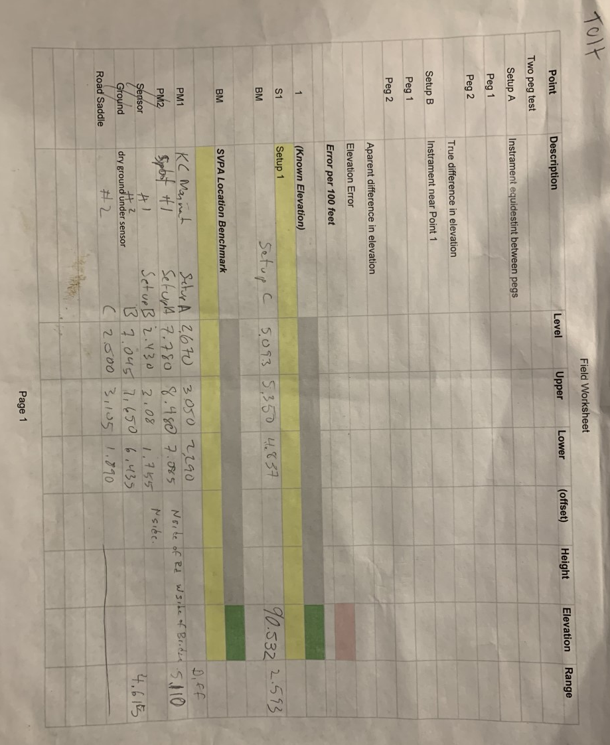

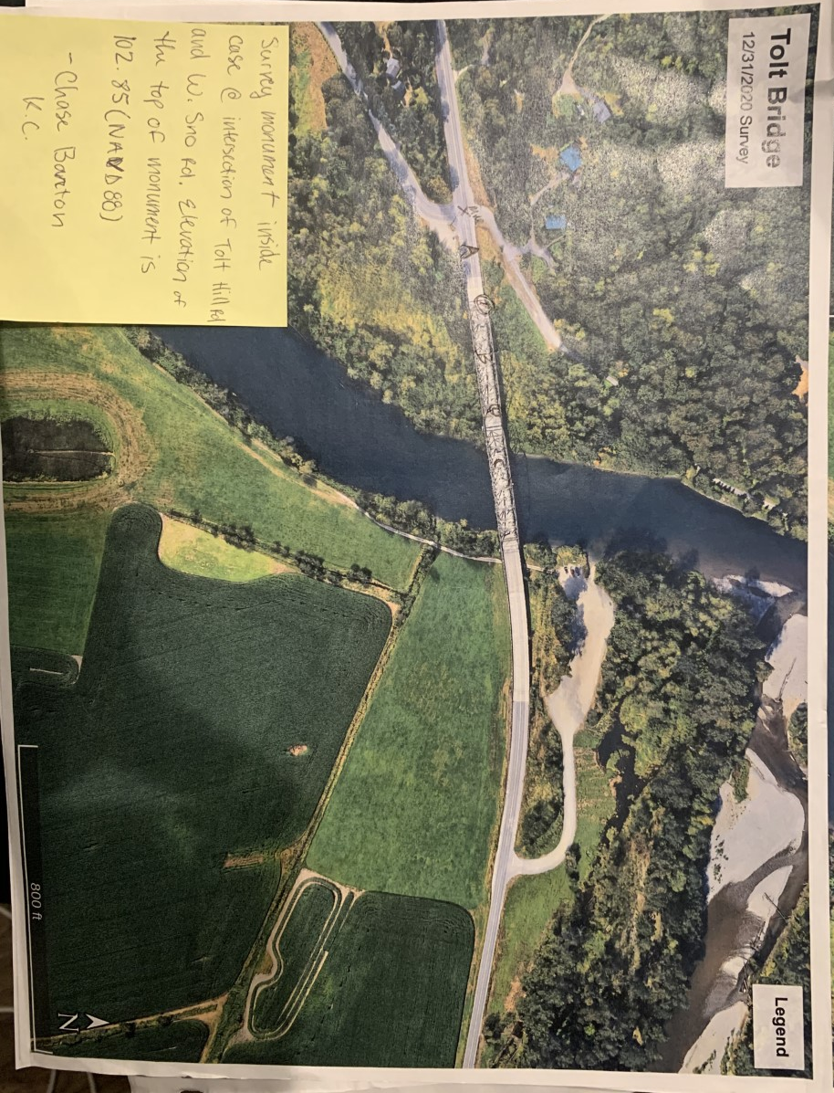
Setup C - AKA sensor location
Measured point
Setup B
Measured point
Setup A
Monument Marker
Illustrating survey points, starting with the King County monument described on sticky note; and ending with the SVPA local benchmark which is the concrete ledge of the bridge as shown in pictures below.
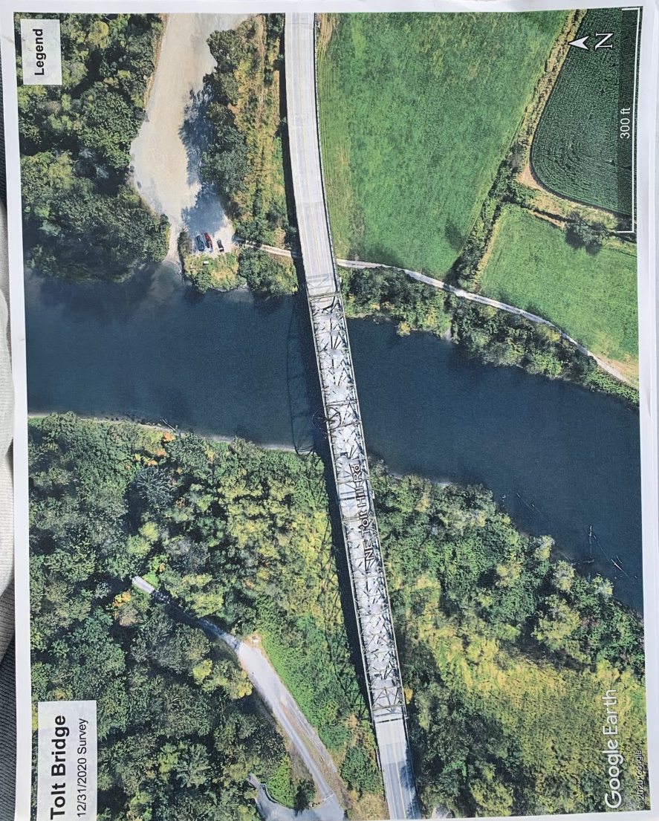

My documentation of location of sensor, determined while out on bridge.

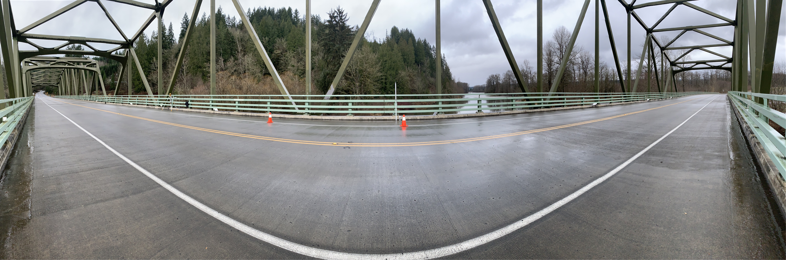
Location of sensor
Picture showing location of sensor. Sensor is hanging off bridge behind the leveling rod.
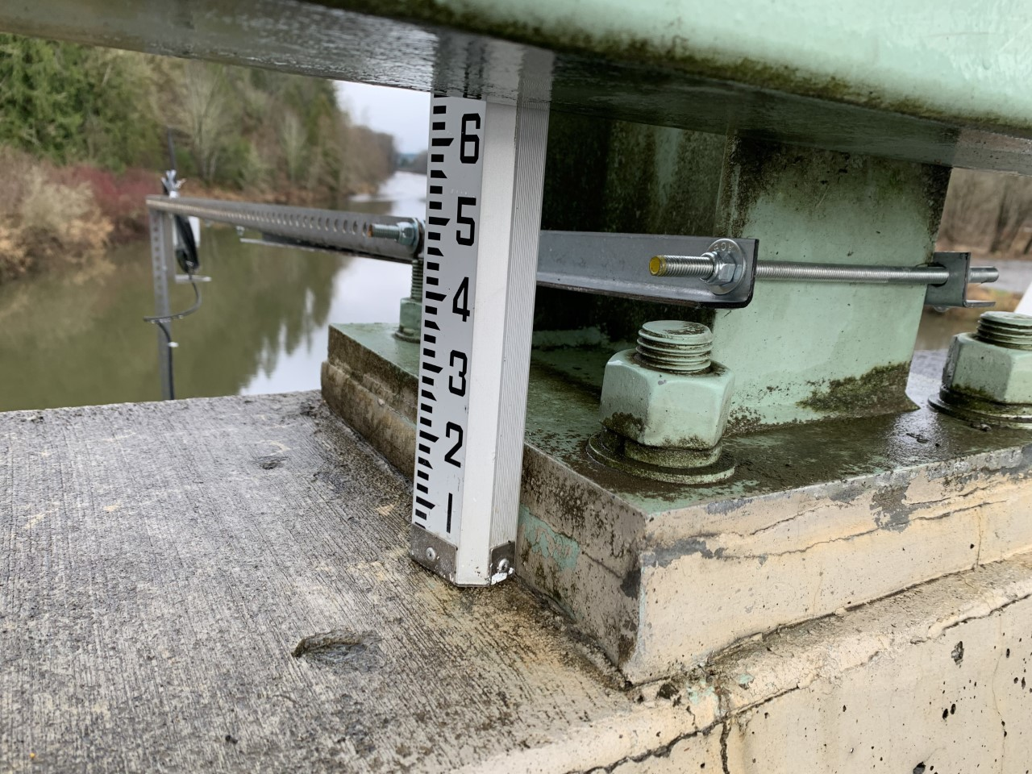
Part of bridge used as SVPA Local BM.

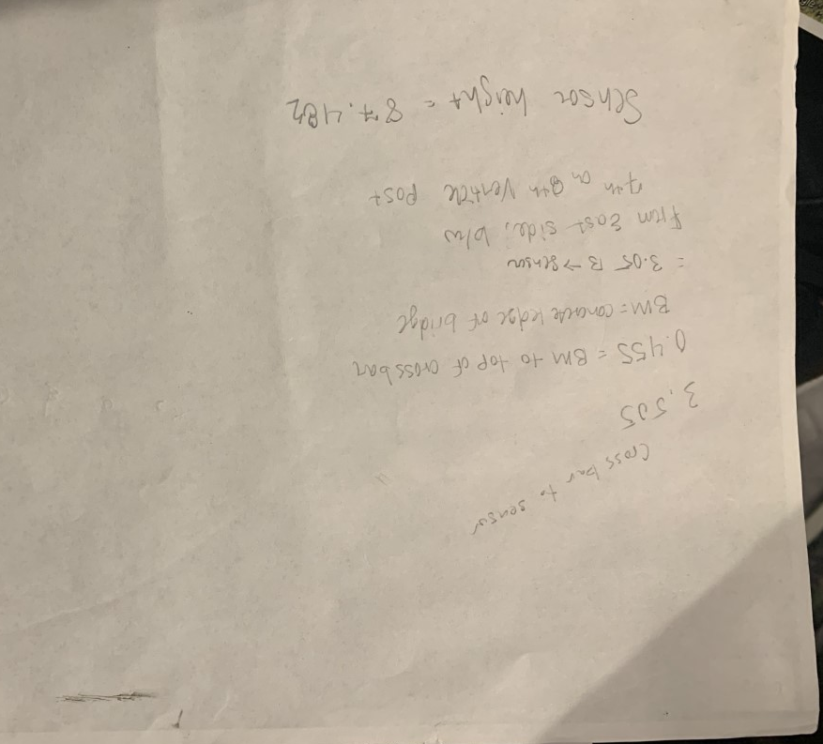

Notes from survey.

