Sno Falls Golf

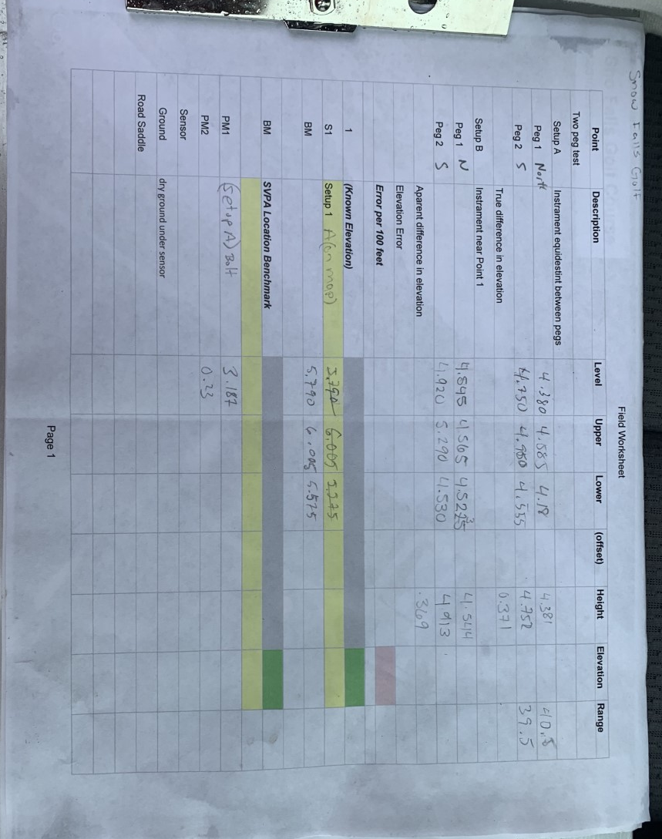

Data from 12/31/2020 Survey at SFG including calibration.

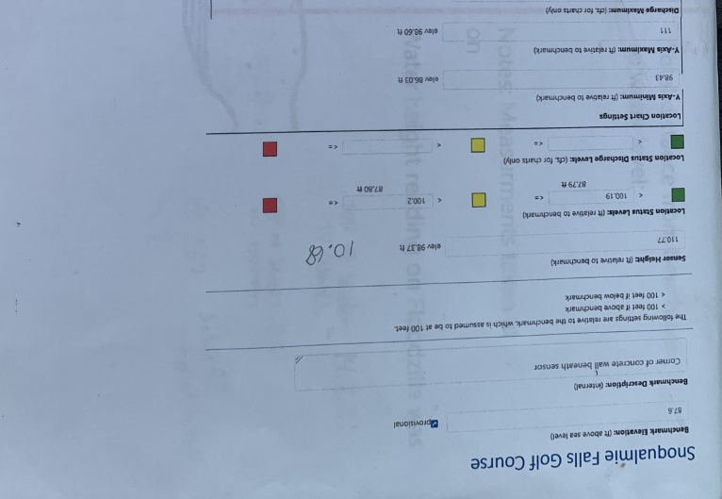

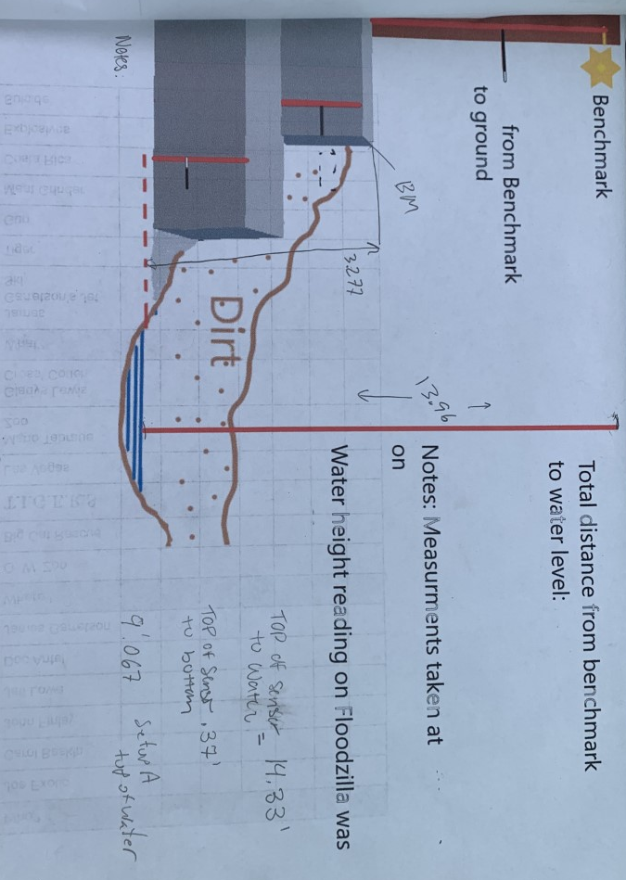

Notes from field.

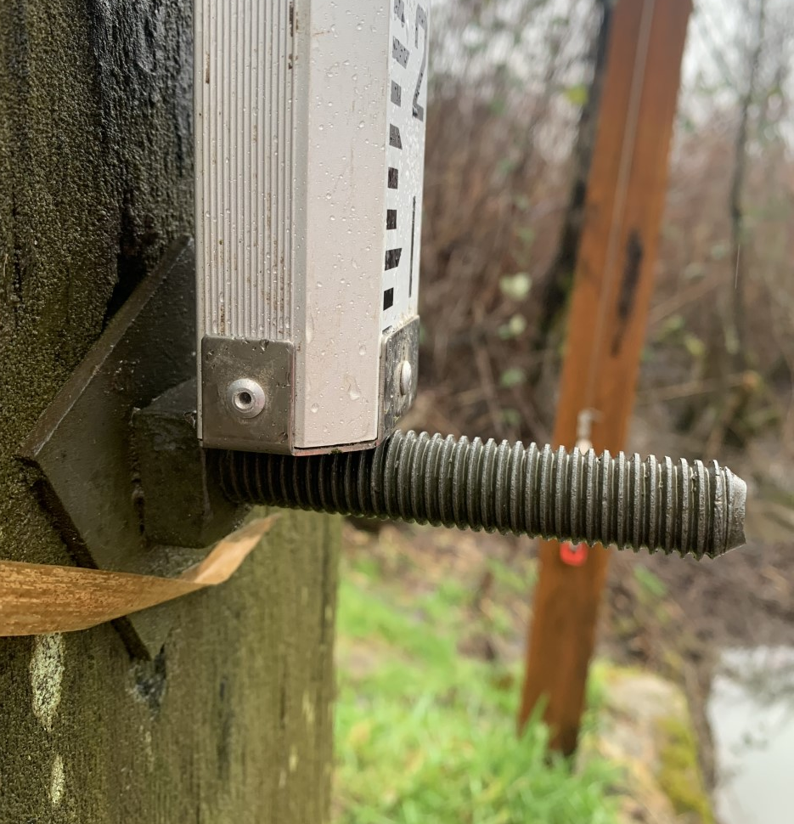

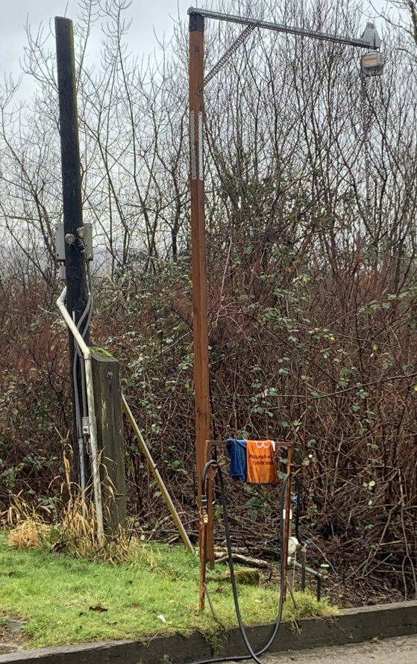

Images of the SVPA Local Bench Mark used at Sno Falls Golf. The top of the bolt, as shown above and in the circle to the left, on the post directly in front of the sensor post is the BM.

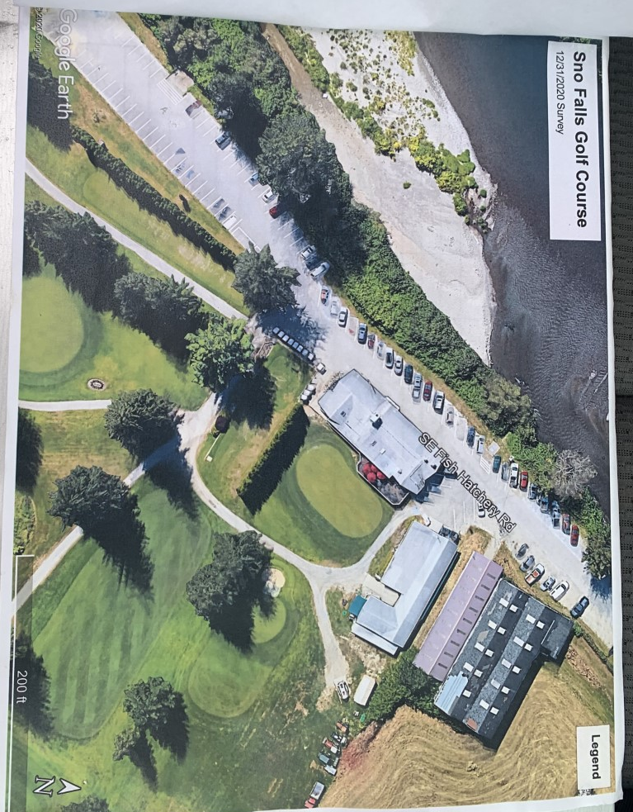
Setup A

