124th W Notes
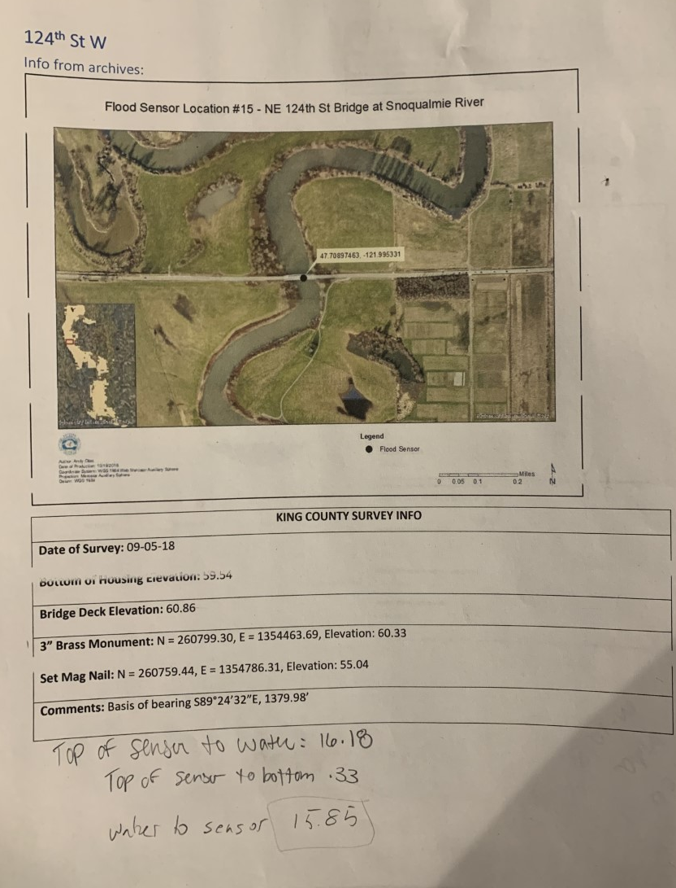
Notes from field. Monument not used.

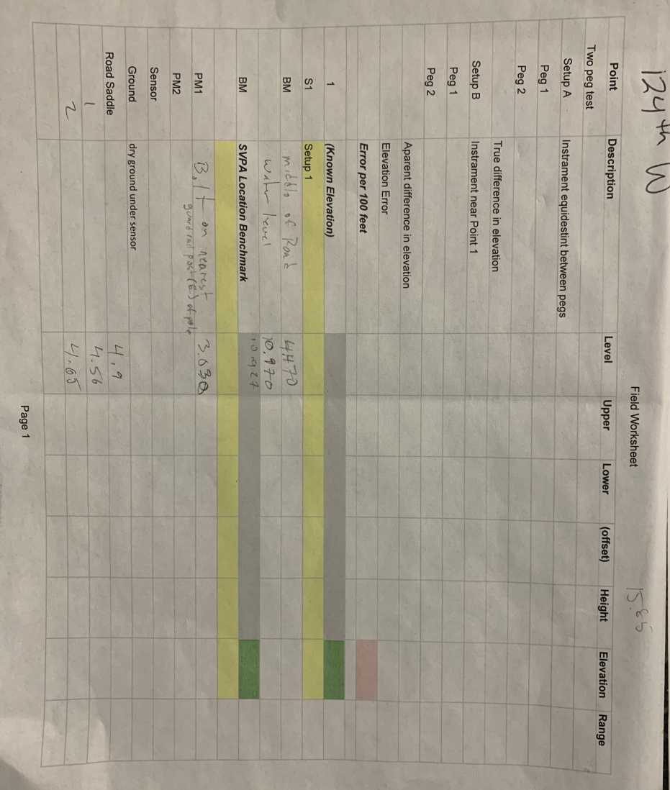
Notes from field.

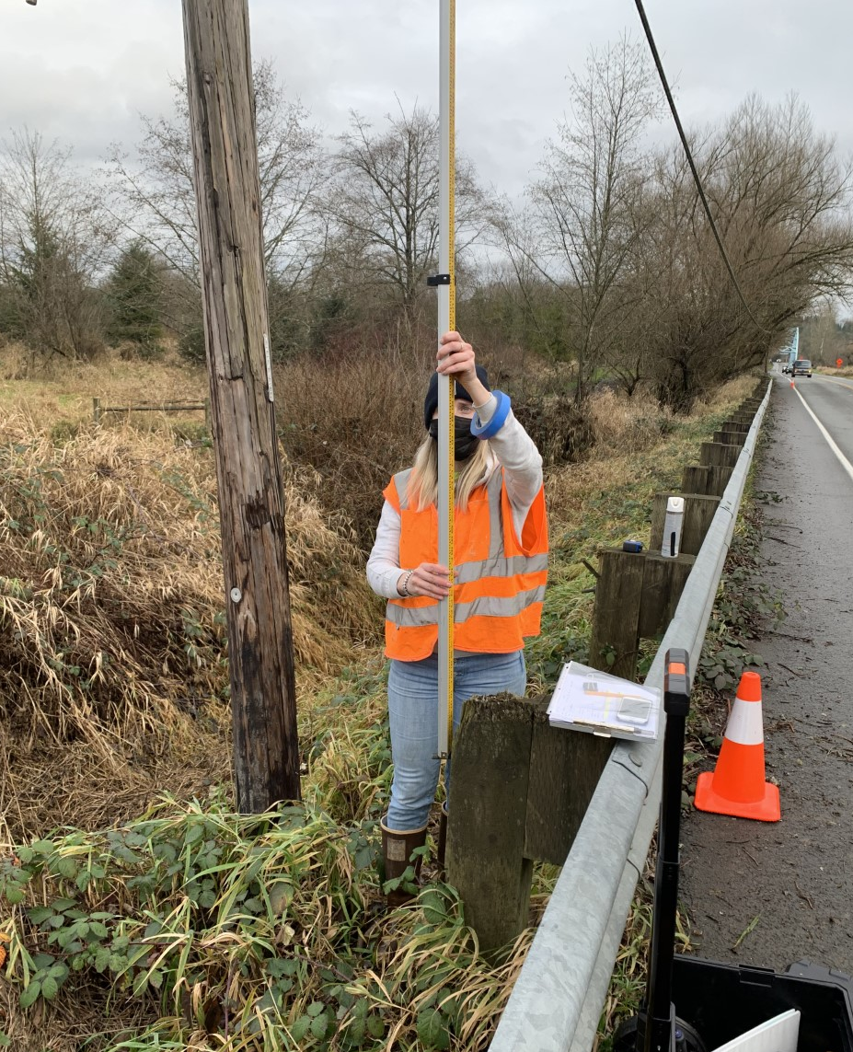
Picture showing the placement of the guard rail bolt used as SVPA local benchmark.

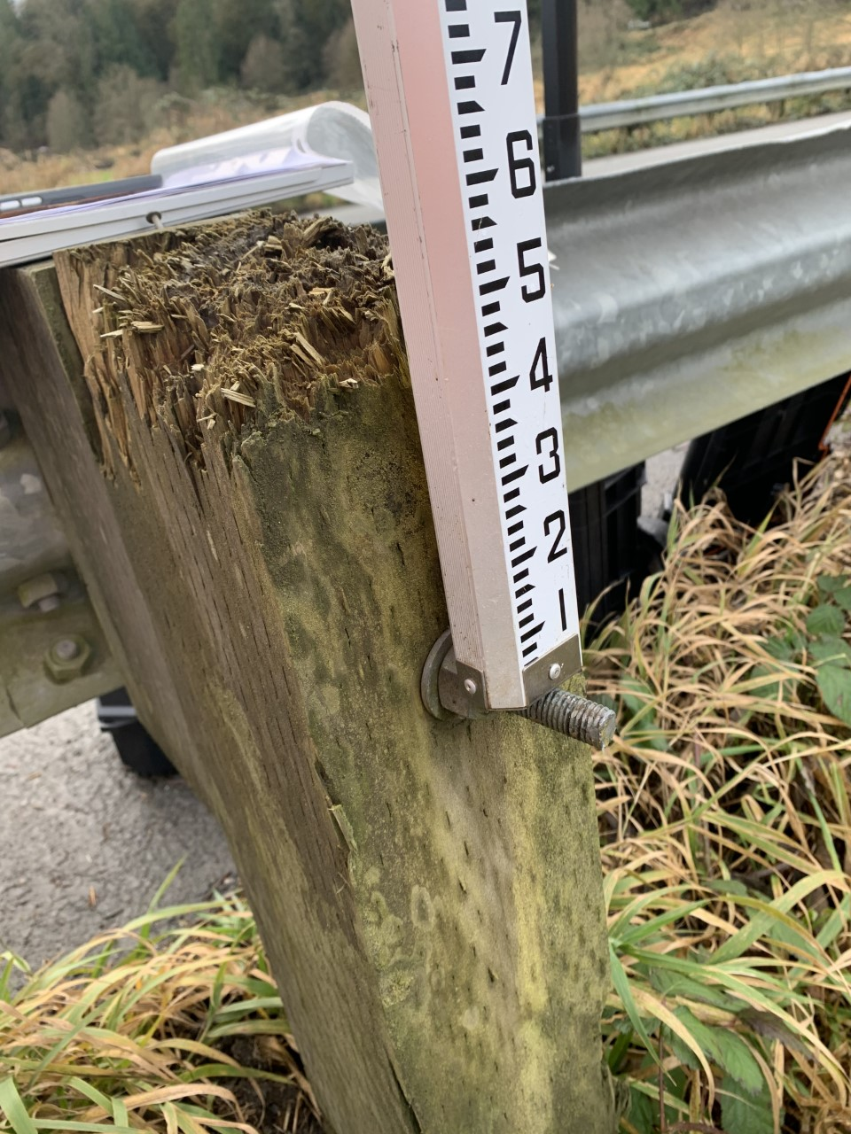
Up close image of bolt used as SVPA local benchmark.

