3. Misc.

A. Integrating with google translate/Adding a "Copy from google translate" button.

This would be the best thing you can ever do to this community, as it would make our workflow much faster!

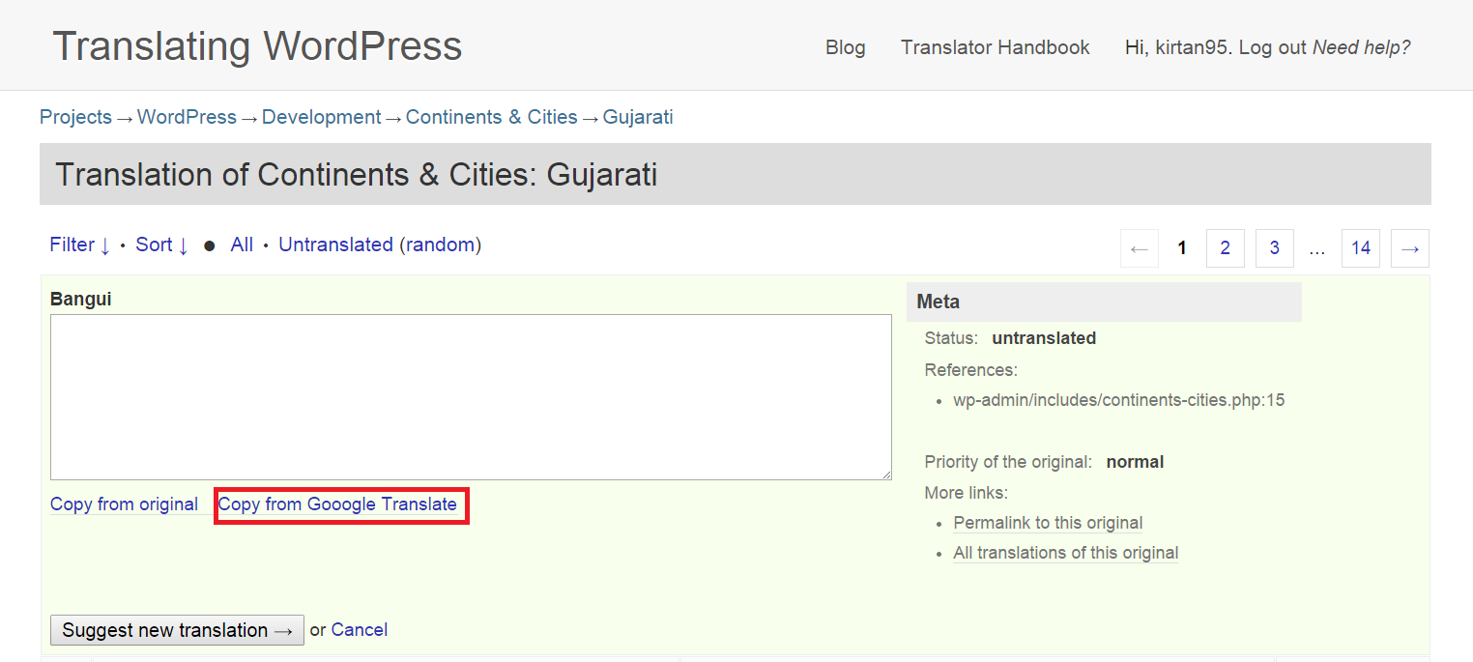
This is my general workflow -

Copy the string > Paste it in google translate > Verify the translation, correct it if mistake is found > Past it on GloatPress.

Such a button would really speed up the workflow.

I guess if community requests, google will allow extra Translate API calls without billing.

----------------------------------------------------------------------------------------------------------------

Summary:

Thanks for hearing out!

Additional comments from slack
markoheijnen @kirtan95: About google translate, that is a good topic for tomorrow. That is something that can be enabled fast but the question is, is it something we want to have. Is the quality really that good

kirtan95 [10:15 AM] @markoheijnen: On the statement - "That is something that can be enabled fast but the question is, is it something we want to have. Is the quality really that good" ?
Yes i know sometimes google translate sometimes provide very ridiculous translation, but most of times it is correct.
kirtan95[10:17 AM]If not correct, at least a part of a whole sentence translated is correct, so all we(translators) have to do is just edit the incorrect part
kirtan95[10:18 AM]or arrange the translated words in proper order.
kirtan95[10:22 AM]This is very helpful especially in case your script of your language is not roman. In that case, you have to change the keyboard input to your language, type each letter carefully to translate the string and then you're done translating a single string.
kirtan95[10:23 AM]All of this could be avoided if you have a "Copy from google translate" button

markoheijnen [3:08 PM] @kirtan95: you should bring up google translate during one of the meetings.

